Full Stack Development Project Documentation
ServiceNow Incident Client Script and UI Policy
Team ID SWTID-2026-5003 | ServiceNow Incident Management
Team member | Contribution
Kaleeswari G | Team Leader; Milestones 4 and 5; Milestone 6 Activity 1
Devibala. A. S | Milestones 1 to 3
Karthika. M | Milestone 6 Activities 2 to 4
Amirtha Varshini S | Milestone 6 Activity 5 and conclusion

1. Introduction
Project Title: Implement Client Script and UI Policy (Incident).
Team ID: SWTID-2026-5003.
Team member | Role / contribution
Kaleeswari G | Team Leader; Milestones 4 and 5; Milestone 6 Activity 1
Devibala. A. S | Milestones 1 to 3
Karthika. M | Milestone 6 Activities 2 to 4
Amirtha Varshini S | Milestone 6 Activity 5 and conclusion

2. Project Overview
Purpose: demonstrate client-side Incident data integrity controls in ServiceNow. Features include a high-impact UI Policy, policy actions for Assignment group and Urgency, an onChange urgency script, onSubmit validation for Assigned To, and onCellEdit protection for State.
The source describes both Assignment group mandatory through the policy action and Assigned To mandatory through the submit script. Treat these as separate controls; confirm whether both are intended.

3. Architecture
Frontend: the ServiceNow Incident form and list interface; no React frontend is used.
Backend: ServiceNow platform services and Incident records; no custom Node.js/Express service is part of this project.
Database: the platform-managed Incident table stores records; no MongoDB schema or direct database integration is supplied.
Client component | Configuration
UI Policy | High Impact Control; table Incident; Impact is 1 - High; active; Reverse if false enabled.
UI Policy Action | Assignment group mandatory; Urgency read-only while condition holds.
onChange | Runs on Impact change; sets urgency to 1 for Impact = 1.
onSubmit | Blocks save when Impact = 1 and assigned_to is empty.
onCellEdit | Rejects list edits to State using alert and callback(false).

4. Setup Instructions
Prerequisites: access to a configured ServiceNow instance with permission to configure UI Policies and Client Scripts, and an Incident table available. No local Node.js or MongoDB installation is required.
Installation/configuration: open System UI > UI Policies and create High Impact Control on Incident; configure Impact = 1 - High and reverse-if-false; add the documented policy actions. Open System UI > Client Scripts and create the active scripts with their stated types and fields. Validate behavior in a non-production instance before promotion. Credentials are managed by the organization and are not included here.

5. Folder Structure
This is a platform configuration project rather than a source-code application with client/server folders. The supplied code ZIP contains milestone evidence screenshots. Configuration records reside in the ServiceNow instance; no export/update-set package was included.

6. Running the Application
Sign in to the authorized ServiceNow instance, open the Incident module, and create or update an Incident. Choose Impact = High to exercise the policy and onChange behavior. Submit with Assigned To blank to exercise the save guard. Test direct State edits from a list separately. No local npm start command applies.

7. API Documentation
No custom HTTP API endpoints are implemented or documented in the supplied project. The scripts use the ServiceNow client-side g_form API and the onCellEdit callback contract. Platform APIs are outside this project scope.

8. Authentication
Authentication and authorization are provided by the ServiceNow instance. The project materials do not describe custom tokens, sessions, identity configuration, or role assignments. Use approved instance access and least-privilege configuration roles.

9. User Interface
Screenshots below show the UI Policy, client scripts, Incident form, and list editing behavior supplied with the project.
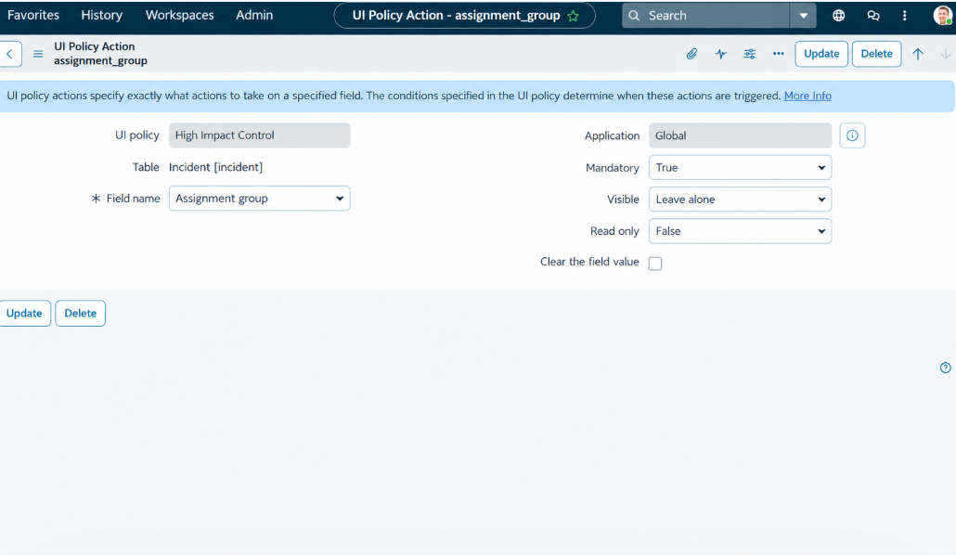
High Impact Control UI Policy.
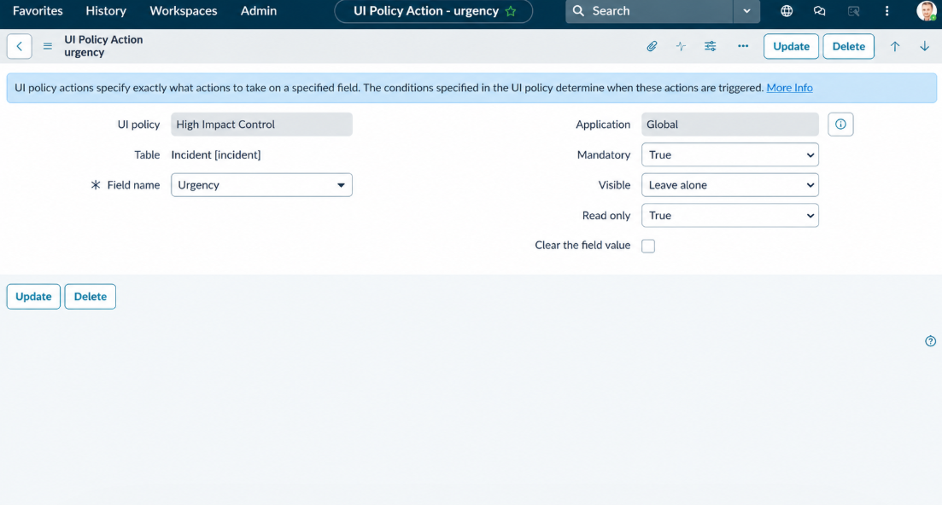
Urgency UI Policy Action.
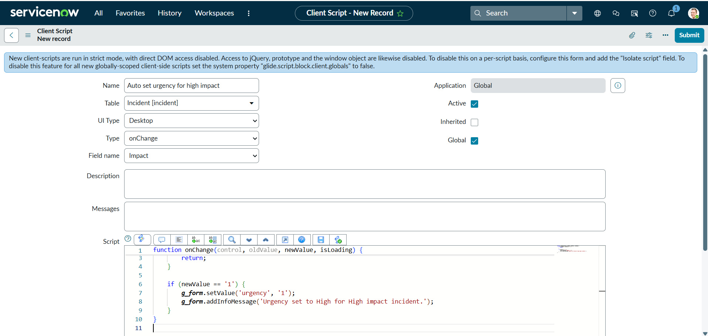
onChange script configuration.
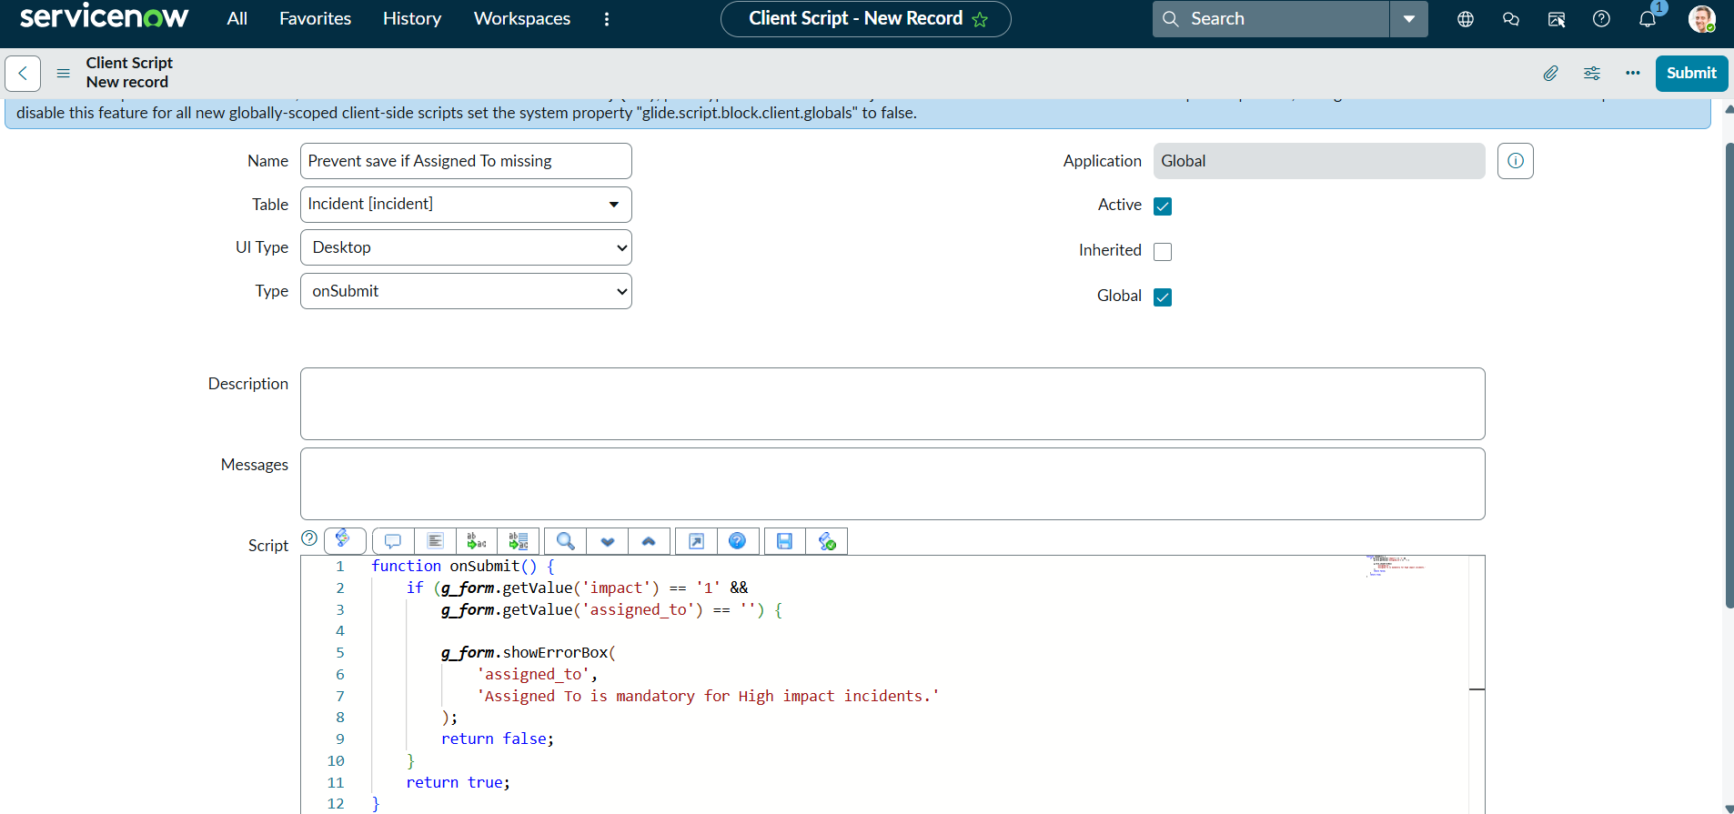
onSubmit validation configuration.
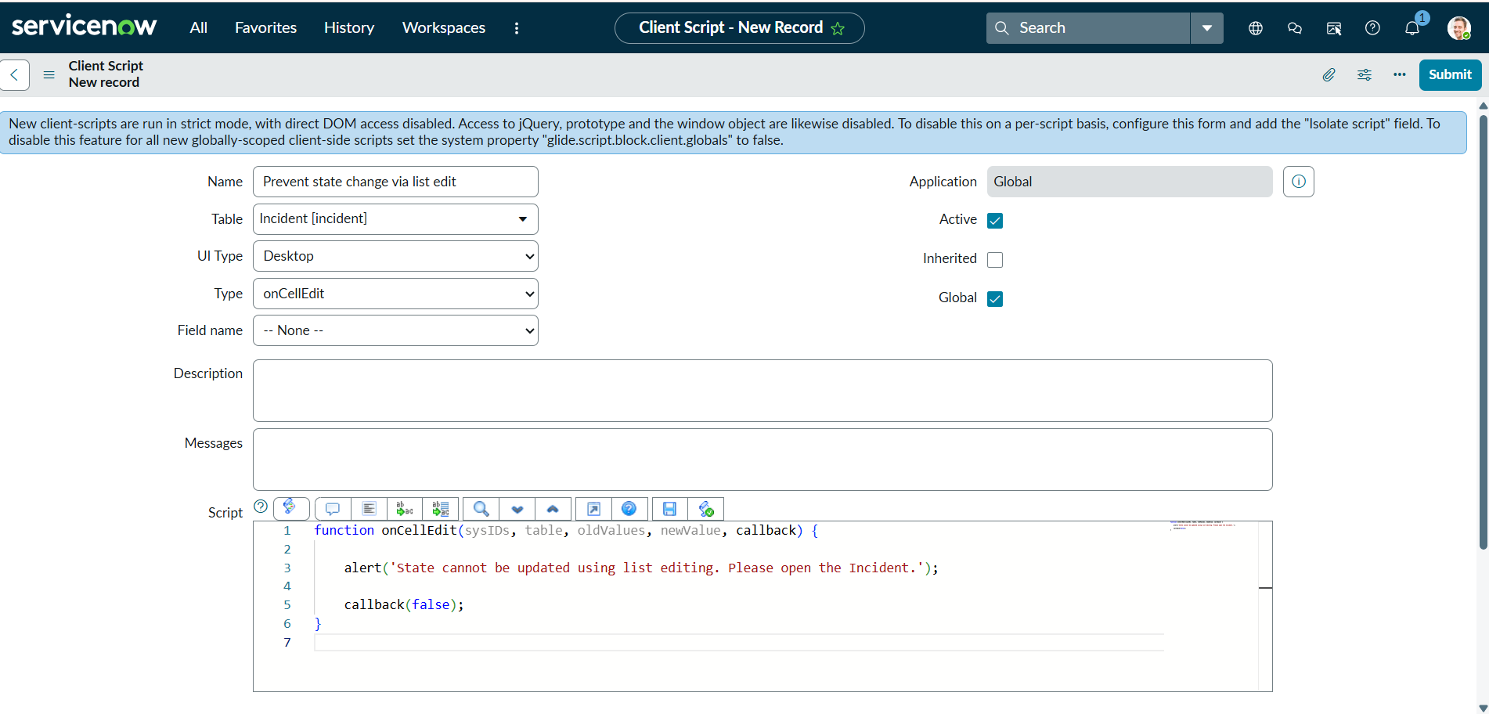
onCellEdit script configuration.
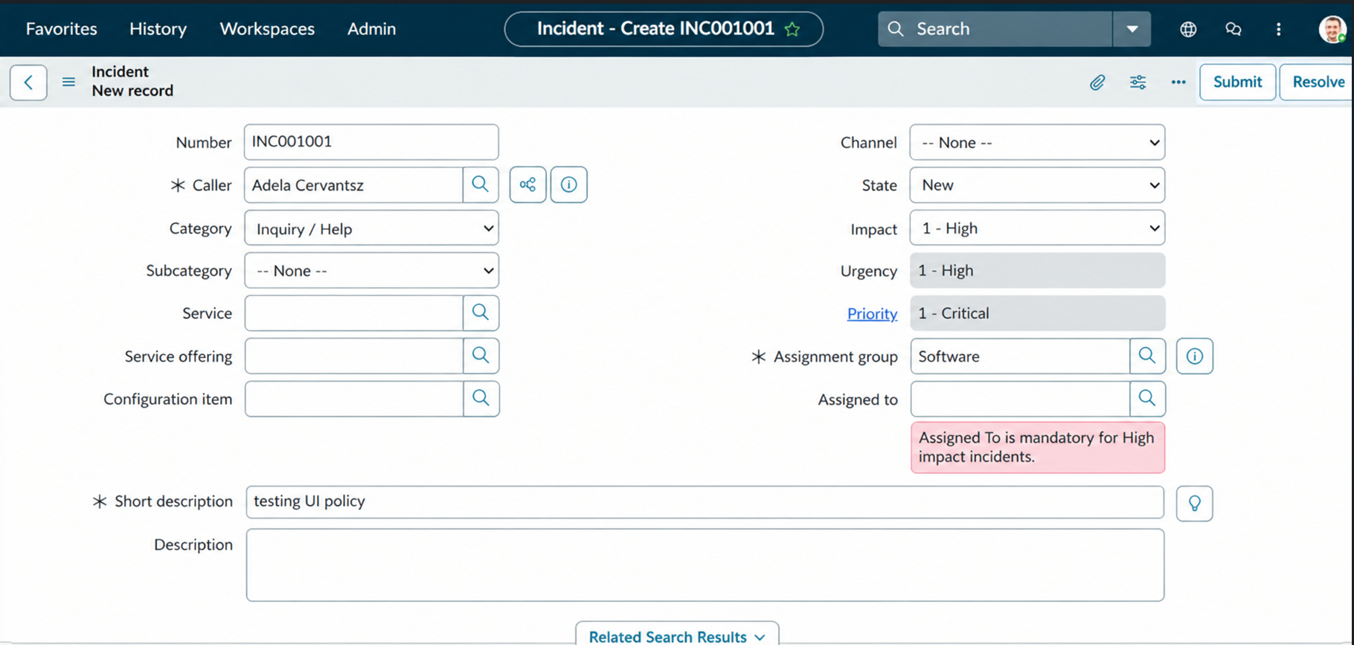
Incident form with validation evidence.
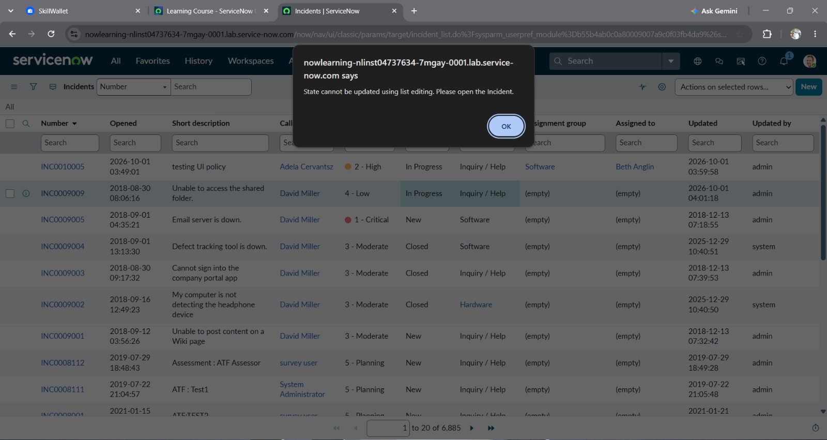
Alert displayed during list State edit.

10. Testing
Test the high-impact policy and reverse condition; urgency auto-population; save prevention when Assigned To is blank for high impact; successful save with an assignee; list-edit rejection for State; and form-based State updates. Supplied screenshots provide configuration and selected interaction evidence, but a completed test log, defect register, and signed approval were not included. Do not treat undocumented test outcomes as passed.

11. Screenshots or Demo
Milestone screenshots are included in Section 9. No public demo URL or repository link was supplied.

12. Known Issues
• The source materials differ on whether Assignment group or Assigned To is the intended mandatory field. The UI Policy action and onSubmit script currently point to different fields.
• Client-side validation does not enforce the same rule for imports, API writes, or other server-side paths.
• No formal defect list, performance measurements, or release sign-off was supplied.

13. Future Enhancements
• Confirm business rule ownership and align mandatory behavior.
• Add server-side validation if required for all update channels.
• Create automated regression/UAT evidence and a controlled deployment package.
• Record a performance baseline and supported-browser checks.

